GİRİŞ SAYFASI YAZISI

MESLEKİ EĞİTİM YENİLİK GELİŞTİRMEYE YÖNELİK STRATEJİK ORTAKLIKLAR kapsamında Four Step For Employment isimli proje hibe almaya hak kazanmıştır.
Proje Ortakları
Politeknika Ikastegia Txorierri S. Coop. Ltd.(BIZKIA) İSPANYA
Kairos Europe:İNGİLTERE
Forave: PORTEKİZ
Határtalanul Iroda kft.: MACARİSTAN

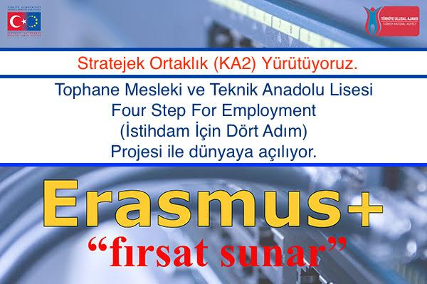

HABERİN İÇERİK SAYFASI

Projenin Konusu: İstihdam İçin 4 Adım projesi mesleki eğitim ve istihdam politikalarını AB boyutunda 4 aşamada incelemeyi hedeflemektedir.
1-İş dünyasının beklentisi ile mesleki eğitim niteliğini karşılaştırmak
2-Mesleki Yeterlilikleri Avrupa yeterlilik çerçevesinde değerlendirmek
3- iş dünyasında yer alacak bireylerin istihdam öncesi Girişimcilik, Cv hazırlama, Temel İş sağlığı güvenliği, Zaman Yönetimi ve İş Verimliliği, Takım Çalışması, İş ahlakı ve Kişisel iş ağı oluşturma becerilerini geliştirecek çok dilli ve sesli dökümanlar hazırlamak.
4-istihdam politikaları ve AB stratejilerinin değerlendirilmesi

OKULUN İNGİLİZCE TANITIMI
Tophane Industrial Vocational High School was established on 29th March 1868 as Reformatory.
Tophane Technical and Industrial High School (TMTAL)
• It was named as Hamidiye Industrial School in 1899.
• In 1910, iron, smoothing and mould ateliers were re-established.
• In 1916, carpentry, fitting, turnery, foundry, wood-turning, modeling, shoe making and forging departments were opened.
• In 1943-1944 educational year, a building where four ateliers and classrooms would locate was constructed as motor atelier was opened.
• In 1952, its name became Bursa Men's Art Institute.
• In 1958, Evening Technician School was opened. Electricity department was opened in 1963-1964 educational year in this school where it used to be machinery department.
• In 1974, the name of the school became Bursa Technical High School and Industrial Vocational High School.
• It was replaced with the regulations brought by "APPRENTICESHIP AND VOCATIONAL EDUCATION LAW" in 1986. With the apprenticeship and vocational education law no 3308 that was acted in 1986, vocational education started in schools and companies.
• In 1987, Tophane Anatolian Technical High School was opened. It continued its education with the department of electronics. Later on, departments of computer and machinery were included in Anatolian Technical High School while CNC department was included in the technical high school.
.In 2012, Industrial Automation Technologies Department was opened in our school so as to follow the state-of-the-art technologies..
TMTAL organizes vocational education for adults within the frame of lifelong learning activities. In accordance with the protocols signed with different institutions, vocational education and training courses are provided within TMTAL
Staff trainings within the frame of the "Regulation Regarding Methods and Basic of the Occupational Health and Security Trainings" that was acted under the scope of the Law of Occupational Health and Security for the companies that are active in the sector are carried out by our institution.
Receiving a qualified vocational education in Bursa that is a city of machinery facilitates to be employed. Therefore the qualification of the vocational education to be received is one of the reasons of why vocational education is preferred. TMTAL has been one of the rooted institutions that serves to this goal and gives the most qualified education on vocational and technical fields since 1868. Being composed of Computerized Machinery Manufacturing, Computer Aided Machine Design, Computer Aided Modeling, Computerized Mould, Metal Works, Metallurgy, Plastic Processing, Textile, Wood, Informatics, Electricity Electronic departments, TMTAL serves education with 4000 students and 280 teachers in the appearance of a factory.

